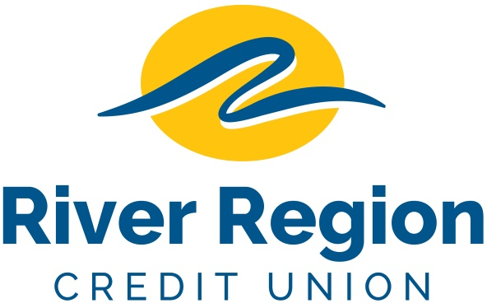

SYSTEMS ADMINISTRATOR – JEFFERSON CITY, MO
- Lead desktop and helpdesk support efforts, making sure all desktop applications workstations, and related equipment problems are resolved in a timely manner with limited disruptions.
- Responsible for the security, maintenance, configuration and reliable operation of computers, network servers, Tier 1 LAN/WAN hardware and virtualization.
- Install and upgrade computer components and software, manage virtual servers and integrate automation processes.
- Perform regular backup operations and implement appropriate processes for data protection, disaster recovery and failover procedures.
- Perform other job related duties as assigned.
- Please email resumes including specific position and availability
to: hr@rrcu.org
or mail to
River Region Credit Union,
Attn: Human Resources
3124 W. Edgewood Dr. Jefferson City, MO 65109. EOE

