SETUP AN EXTERNAL ACCOUNT AND MAKE A PAYMENT IN ONLINE BANKING

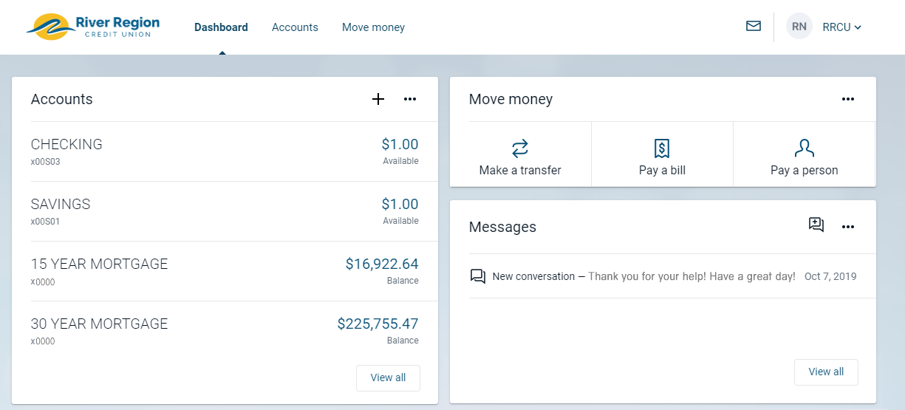

To get started, click on “Accounts”.
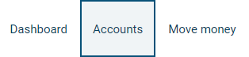

On the right hand side of the screen, click "Add an external transfer account".

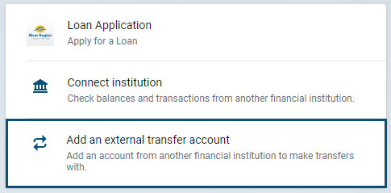

Enter the following information:
Account Name - This can be anything you desire in order to easily identify your account
Routing Number - The routing number of the financial institution you are adding
Account Number - The account number you would like to add
Account Type - Choose if you’re adding a checking or savings account

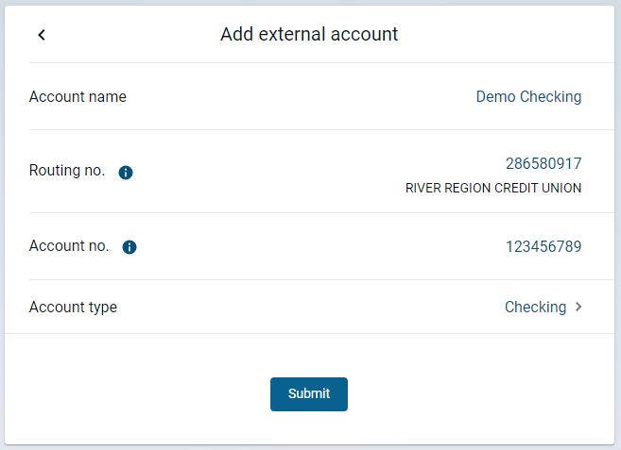

At this point, River Region will send two micro-deposits to the external checking or savings account that you just added. These micro-deposits will appear in your external account within 1 - 5 business days.

Once you have received the micro-deposits in the external account, log back into your River Region home banking.

Click on “Move Money”, and then “Transfers”.

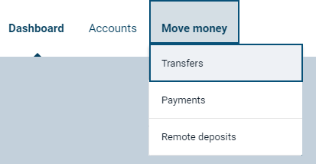

Click “External Accounts”, and then choose the external account you are verifying.
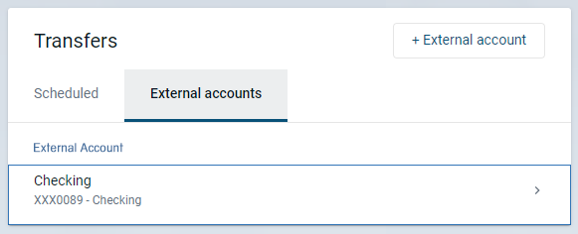

Enter the two micro-deposit amounts that you received and choose “Confirm”.

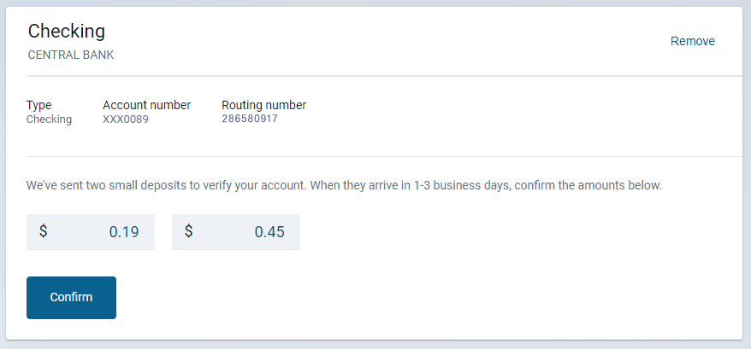

The external account will now be set up for use!

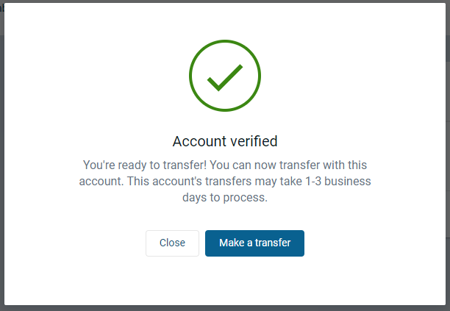

To schedule a payment, click on “Accounts”.

Choose the loan you would like to make a payment on.

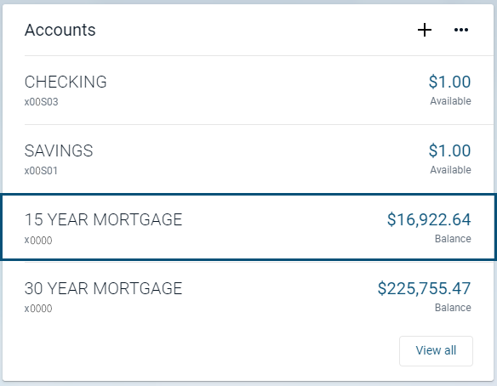

On the right hand side, choose Transfer.

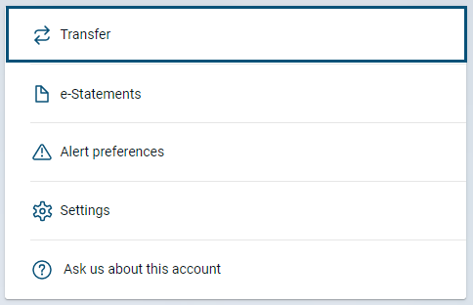

Choose the “From” account, enter the amount, and select Submit for a one-time transfer, or choose “More Options” to set a date and frequency if you would like the transfer to recur.

