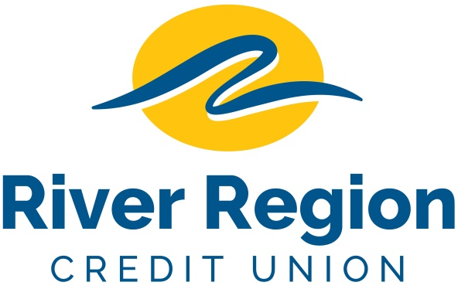

MEMBER SERVICES REPRESENTATIVE – ASHLAND, MO
- To assist members with their financial transactions, involving paying and receiving cash and other negotiable instruments.
- Identify and develop cross sell opportunities with members and nonmembers of the credit union.
- Receives and processes customer financial transactions including deposits, withdrawals, loan payments, selling of money orders to members, transfers from member accounts as directed and maintaining member records.
- Welcomes members and provides routine information concerning services and directs member to appropriate department for specific information and service.
- Performs other job related duties as assigned.
- Please email resumes including specific position and availability
to: hr@rrcu.org
or mail to
River Region Credit Union,
Attn: Human Resources
3124 W. Edgewood Dr. Jefferson City, MO 65109. EOE

