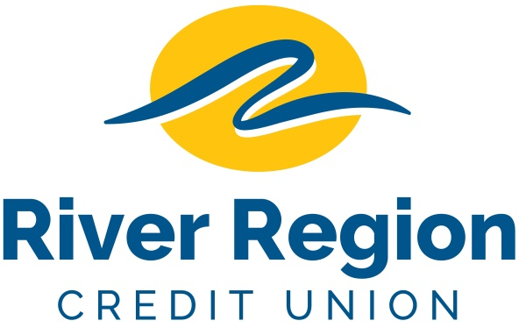

REAL ESTATE LOAN ORIGINATOR – JEFFERSON CITY, MO
- Seeking individual to market mortgage lending products to companies and individuals.
- Assist members with their mortgage lending needs: analyze loan requests and make credit decisions based on mortgage lending policy.
- Good communication skills and sales experience required
- Full time position with excellent benefits
- Please email resumes including specific position and availability
to: hr@rrcu.org
or mail to
River Region Credit Union,
Attn: Human Resources
3124 W. Edgewood Dr. Jefferson City, MO 65109. EOE

