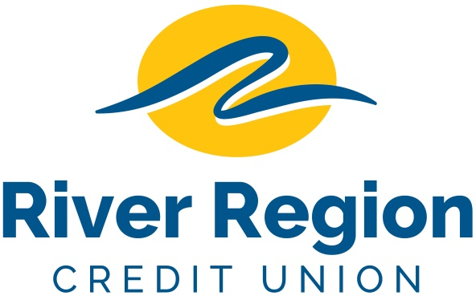

FINANCIAL SERVICES OFFICER – COLUMBIA, MO
- To promote a positive service relationship and improve account engagement with members and nonmembers
- Explains services to potential consumer and commercial account customers to generate additional business and to promote positive public relations.
- Resolves account-related questions and concerns with members and nonmembers.
- Removes, counts, and records cash from automated teller machine, ITMs and other branch technology.
- Evaluates all branch activities to ensure they are in compliance with established Credit Union policies, procedures, and objectives; recommends changes to manager.
- Performs other job related duties.
- Please email resumes including specific position and availability
to: hr@rrcu.org
or mail to
River Region Credit Union,
Attn: Human Resources
3124 W. Edgewood Dr. Jefferson City, MO 65109. EOE

