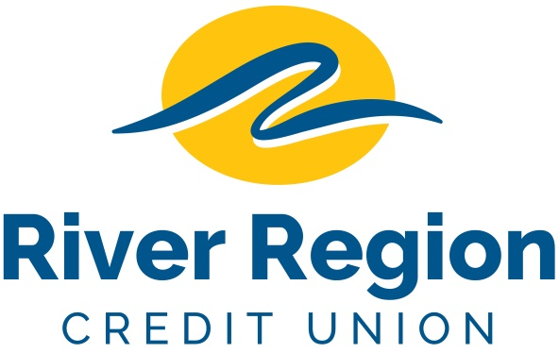

PART-TIME TELLER - JEFFERSON CITY, MO

- Become a team member for a retail
banking branch where
unlimited opportunities are available.
- Applicants must display a high energy level in a
fast-paced environment delivering outstanding
member service and demonstrate
excellent communication skills.
- Weekdays including rotating Saturdays.
- Please email resumes including specific position and availability
to: hr@rrcu.org
or mail to
River Region Credit Union,
Attn: Human Resources
3124 W. Edgewood Dr. Jefferson City, MO 65109. EOE

